CSA1715-ARTIFICIAL INTELLIGENCE
LAB PROGRAM- 12
06-08-2026
12. Write the python program for Tic Tac Toe game.

Aim
To implement the Tic Tac Toe Game in Python, where two players take alternate turns to place their symbols (X and O) on a 3×3 board. The objective is to identify the winner by checking rows, columns, and diagonals or declare the game as a draw if no winning condition is met.

Algorithm
- Create an empty 3×3 Tic Tac Toe board.
- Allow players X and O to take turns entering the row and column numbers.
- Place the player's symbol in the selected empty cell.
- After every move, check all rows, columns, and diagonals for a winning combination.
- If a player forms three identical symbols in a row, column, or diagonal, declare that player as the winner.
- If all cells are filled and no player wins, declare the game as a draw.
- Display the final board and the game result.

Program
b=[[' ']*3 for _ in range(3)]

def show():
for i in b:
print(*i)

for p in ['X','O']*5:
show()
r=int(input("Enter row (0-2): "))
c=int(input("Enter column (0-2): "))
if b[r][c]==' ':
b[r][c]=p
for i in range(3):
if all(b[i][j]==p for j in range(3)) or all(b[j][i]==p for j in range(3)):
show()
print(p,"Wins")
exit()
if b[0][0]==b[1][1]==b[2][2]==p or b[0][2]==b[1][1]==b[2][0]==p:
show()
print(p,"Wins")
exit()
show()
print("Draw")

Input and Output:
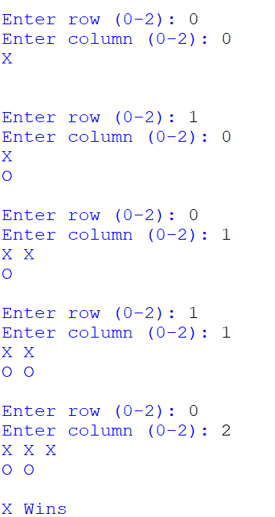

Result:
The Tic Tac Toe Game was implemented successfully using Python. The program allowed two players to enter their moves alternately, updated the game board after each move, checked for winning conditions after every turn, and correctly declared the winner or a draw based on the game outcome.

